Project Gate Page

A18 – Group 111 - Icook

**Dor Shabat – דור שבת - 316575620  
Yuval Rozner – יובל רוזנר - 207756552  
Niv Dahan – ניב דהן - 308215086  
Nitzan Ezra – ניצן עזרא - 208697334**

**Icook** is a web application that offers an interactive platform for cooking enthusiasts. It features a diverse collection of recipes, each with detailed instructions for preparation. Users can navigate through these recipes, select one, and follow a step-by-step guide to cook a variety of dishes. The application includes functionality to adjust ingredient quantities based on the desired number of servings, catering to different cooking needs. Additionally, Icook is designed to be responsive, ensuring a consistent experience across various devices. The interface incorporates a straightforward navigation system, facilitated by a dedicated navigation bar, enabling users to explore recipes and cooking guides seamlessly.

**Key Features:**

* Recipe Browsing: Users can explore a curated list of recipes on the homepage.
* Detailed Instructions: Each recipe comes with comprehensive preparation steps and ingredient lists.
* Interactive Cooking Guide: The CookWithMe feature guides users through the cooking process with a visual progress bar.
* Responsive Design: Optimized for various device sizes, providing a consistent user experience across desktops, tablets, and mobile devices.
* Accessibility: Navigation controls and UI elements are designed to be accessible and user-friendly.

**Technologies Used:**

* **React:** A JavaScript library for building user interfaces with component-based architecture.
* **Tailwind CSS:** A utility-first CSS framework for styling the application.
* **React Router:** A standard library for routing in React, allowing navigation between different components.
* **Database:** A Json file used as a database for all the recipes information.

Direct link to the website: <https://yuvalrozner.github.io/Icook>

Link to the repository: <https://github.com/YuvalRozner/Icook>

Link to MTW: <https://www.morethanwallet.com/app/689>

**Assignments**

|  |  |  |
| --- | --- | --- |
| **שם חבר צוות** | **משימות שהוקצו** | **משימות שהושלמו** |
| **דור** (מהנדס מערכת) | 1. ארכיטקטורת האתר – מעבר לreact . 2. כתיבה מחדש של חלק מהקוד ב react . 3. כתיבת תיק – user guide. | כל המשימות |
| **יובל** | 1. ארכיטקטורת האתר – מעבר לreact . 2. כתיבה מחדש של חלק מהקוד ב react . 3. כתיבת תיק programing manual . | כל המשימות |
| **ניצן** | 1. ארכיטקטורת האתר – מעבר לreact . 2. כתיבה מחדש של חלק מהקוד ב react . 3. עדכון use case | כל המשימות |
| **ניב** | 1. ארכיטקטורת האתר – מעבר לreact . 2. כתיבה מחדש של חלק מהקוד ב react . 3. עדכון דרישות | כל המשימות |

**Requirements**

|  |  |
| --- | --- |
| **FR** | |
| System shall allow users to choose a recipe from a recipes list. | |
| System shall allow users to view detailed recipes. | |
| System shall feature a "Cook with Me" interactive cooking assistant. | |
| System shall offer Manual mode. | |
| System shall offer Automatic mode. | |
| System shall provide a progress bar. | |
| System shall allow users to control the timer. | |
| System shall enable users to adjust recipe quantities. | |
| **NFR** | |
| **Requirement** | **Type** |
| The website shall be user-friendly, with intuitive navigation and a responsive design suitable for various devices (desktop, tablet, smartphone). | Usability |
| The website shall provide images for recipes, steps instructions and cooking progress. | Usability |
| The website shall load within 3 seconds on standard broadband connections, and recipe steps shall advance smoothly in "Automatic Mode" without lag. | Performance |
| The system shall support an increasing number of users and recipes without degradation in performance or usability. | Scalability |
| The website shall be available 24/7 | Availability |
| The website’s codebase shall be structured and documented to facilitate easy updates, bug fixes, and feature enhancements. | Maintainability |
| The website shall offer customization options for users, such as theme selection, layout preferences, and notification settings, to enhance the personal user experience. | Customization |
| Adjust recipe quantities will based on the number of serving the user choose. | Customization |
| Manual mode, Automatic mode, Progress bar, timer, timer controllers, recipe adjustments – will all be a part of the "Cook with Me" feature. | Structure |
| The website must maintain high-quality, engaging, and error-free content to attract and retain visitors. | Content Quality |
| The design should focus on simplicity and ease of use, avoiding unnecessary elements. | Design |

**Architecture**

**Use Case**

**Folder and Files Diagram :**

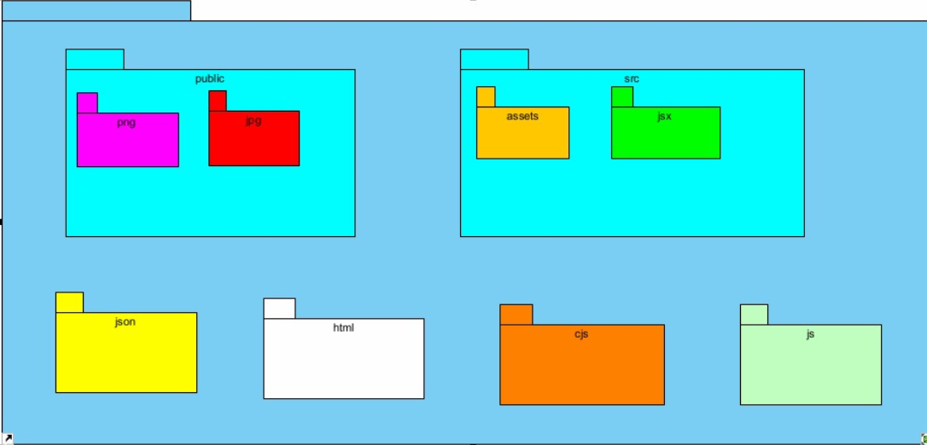

**Database Structure:**  
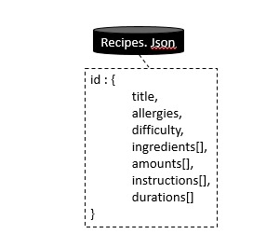

# Programmer Manual

A18

Dor Shabat - 316575620  
Yuval Rozner - 207756552  
Niv Dahan - 308215086  
Nitzan Ezra - 208697334

Table of Contents

1. Introduction 9

1.1 System Architecture Overview 9

1.1.1 Key Components 9

1.1.2 Key Libraries and Frameworks 9

2. Key Files and Folders: 10

2.1 Index.html 10

2.2 recipes.json 10

2.3 public folder 10

2.4 src folder 10

2.5 package.json 10

3. Key Components 11

3.1 App.jsx 11

3.2 Always loaded components 11

3.2.1 Head.jsx 11

3.2.2 NavigationBar.jsx 11

3.2.3 Tail.jsx 11

3.3 Specific page components 11

3.3.1 RecipesList.jsx 11

3.3.2 Recipe.jsx 12

3.3.3 CookWithMe.jsx 12

4. Key functions 13

4.1 Dynamic Routing 13

4.2 State Management for Recipe Interaction 13

4.3 Ingredient Scaling 13

4.4 Accessibility and Navigation 13

4.5 Recipe Selection 14

4.6 Persistent UI Elements 14

## Introduction

This manual serves as a guide for developers working on the Icook – Interactive Cooking Assistant Web Application stored on GitHub repository and hosted on GitHub Pages. It details the Web architecture, code organization, interaction between the components of React, and how to use and modify the React components with tailwind for changing the UI.

### System Architecture Overview

The application integrates ReactJS for web coding, a json file as a database for storing and retrieving data, and tailwind as a UI design framework.

#### Key Components

* **ReactJS:** the website coded using React framework and uses the components architecture.
* **Database:** Json file used as a data file storing all the recipes the websites can offer.
* **UI**: the UI design by using tailwind framework.

#### Key Libraries and Frameworks

* **Vite**: For creating web application project.
* **ReactJS:** For developing web components for UI elements.
* **Tailwind:** For designing the UI elements.
* **GitHub Pages:** For hosting the website UI.

## Key Files and Folders:

We utilize Vite to create our project, which offers a template for a web project using the React framework.

### Index.html

* **Single page website:** The single html page of our project, which determine the website meta data and defining a root used for the React UI components.

### recipes.json

* **Database:** Recipes data and information stored as a dictionary in a Json file and being imported in the JS code.
* **Structure (dictionary structure):**

recipes : {  
 id : {  
 title,   
 allergies,  
 difficulty,  
 ingredients[],  
 amounts[],  
 instructions[],  
 durations[]  
 },   
 id : {  
 title,   
 allergies,  
 difficulty,  
 ingredients[],  
 amounts[],  
 instructions[],  
 durations[]

}, ….  
}

### public folder

* **Shared Files:** The public folder stored the website images, the recipes and dishes pictures and the favicon icon file, the logo image file, and more.

### src folder

* **Components:**  The src folder, holds all the React UI components of our website. (full components descriptions in the next section).

### package.json

* **Scripts:** Hold the project scripts like: build, deploy and etc..
* **Dependencies**: Hold the project dependencies like: react version, react-dom, react-router-dom, and tailwind framework version.

## Key Components

The Icook website uses React framework for rendering UI components written in JS on a single html page. Those components designed by using Tailwind framework for adding css class during the JSX code.

We implement some components as a reusable component like the head, tail, navigation bar and more.

**Descriptions of some of those main components:**

### App.jsx

* Root component of the Icook application.
* Utilizes `react-router-dom` for handling routing.
* Imports recipe data and initializes state for titles derived from the data.
* Defines routes for home, individual recipes, and CookWithMe view.
* Ensures `Head` and `Tail` components are always rendered across different routes.

### Always loaded components

These components are foundational to the Icook website and persist across all views, providing a consistent user experience:

#### Head.jsx

* Displays the website's logo.
* Acts as a navigational link to the home page.
* Responsive design that adapts to various screen sizes.

#### NavigationBar.jsx

* Provides back and home navigation buttons.
* Displays the current page title.
* Uses `useHistory` hook for back navigation.
* Responsive layout with hover effects for buttons.

#### Tail.jsx

* Serves as the website's footer.
* Provides copyright information.
* Lists the names of the creators.
* Simple, responsive design for text alignment and visibility.

### Specific page components

These components are specific to certain routes or pages within the Icook website and are rendered according to user interaction and navigation:

#### RecipesList.jsx

* Displays recipes in a responsive grid layout.
* Handles click events to navigate to recipe details.
* Each recipe item includes an image and a label.
* Implements shadow and hover effects for interactivity.

#### Recipe.jsx

* Detailed view of a selected recipe.
* Shows allergies, difficulty level, ingredients, amounts, and instructions.
* Features a dish count selector for ingredient amount scaling.
* Responsive design with elements and text scaling for various devices.

#### CookWithMe.jsx

* Interactive step-by-step cooking guide.
* Displays instructions, estimated duration, and images for each step.
* Includes a progress bar indicating cooking progress.
* Navigation buttons to move between steps.
* Images and layout responsively adjust to the screen size.

## Key functions

In this section, we outline several important functionalities that are integral to the Icook website, enabling interactive user experiences and the site's core features.

### Dynamic Routing

* Utilizes react-router-dom to handle navigation between different components without reloading the page.
* Implements parameterized routes to display recipe details dynamically based on user selection.

### State Management for Recipe Interaction

* Manages the state of the current recipe step within CookWithMe.jsx, allowing users to progress through the cooking instructions.
* Utilizes useState for state management and useMemo to calculate the progress percentage based on completed steps.

### Ingredient Scaling

* Provides functionality within Recipe.jsx to adjust the quantities of ingredients based on the number of dishes the user wishes to prepare.
* The handleDishChange function updates the state based on the user's selection from the dropdown.

### Accessibility and Navigation

* The NavigationBar.jsx component employs the useHistory hook to programmatically navigate users back to the previous page, enhancing accessibility and user experience.

### Recipe Selection

* In RecipesList.jsx, the handleClick function is responsible for redirecting users to the detailed view of the clicked recipe, showcasing the use of imperative navigation.

### Persistent UI Elements

* The always-loaded components Head and Tail provide a persistent UI experience, with Head.jsx showcasing logo rendering and navigation home functionality.

These functionalities represent a cross-section of the dynamic and interactive nature of the Icook website, demonstrating both frontend routing and state management capabilities, as well as user interaction design. The code snippets provide insight into how these features are implemented within the React framework, leveraging the utility of hooks and the Tailwind CSS framework for styling.

**A18 – User Guide**

**Dor Shabat - 316575620  
Yuval Rozner - 207756552  
Niv Dahan - 308215086  
Nitzan Ezra - 208697334**

**Table of Contents**

Opening the website 17

Home screen: 17

Choosing a recipe 18

Recipe screen: 18

"Back" and "Home" buttons 20

Changing Number of Dishes 22

"Cook With Me!" button 23

Cook With Me 23

"Back" and "Home" buttons 24

"Prev" and "Next" buttons 25

# Opening the website

In order to open the site, click on the link <https://yuvalrozner.github.io/Icook>

# Home screen:

|  |  |
| --- | --- |
| **computer display** | **phone display** |
|  |  |

## Choosing a recipe

In this section you can choose a desired recipe to prepare, you can see that each recipe has a name and a picture that represents it.

For example, click on the recipe called Chocolate Cake marked in the picture.

|  |  |
| --- | --- |
| **computer display** | **phone display** |
|  |  |

# Recipe screen:

After selecting a recipe, you will be taken to a detailed page for that dish. Here, you can see:

1. Allergies: Lists common allergens in the recipe (e.g., Dairy, Gluten).
2. Difficulty: Indicates how difficult the recipe is to make (e.g., Intermediate).
3. Ingredients: Provides a detailed list of all the ingredients needed.
4. Instructions: Step-by-step instructions on how to prepare the dish

|  |  |
| --- | --- |
| **computer display** | **phone display** |
|  |  |

## "Back" and "Home" buttons

In any point of time you can press "Back" or "Home" to return to the homepage.

|  |  |
| --- | --- |
| **computer display** | **phone display** |
|  |  |

Or, you can also click on the logo to return to the homepage.

|  |  |
| --- | --- |
| **computer display** | **phone display** |
|  |  |

## Changing Number of Dishes

On this page, you can adjust the "Number of Dishes" you want to make, and the ingredient quantities will update accordingly.

|  |  |  |  |
| --- | --- | --- | --- |
|  | |  | **instruction** |
| computer display | | phone display | Click on the "select" button |
|  | |  |
|  | | | Choose the desired amount |
| To | From | | The amounts will change accordingly |
|  |  | |

## "Cook With Me!" button

There's also a fun "Cook With Me!" feature where, presumably, you can get additional help or interactive guidance.

All on this feature in the "Cook With Me" section next.

# Cook With Me

Cooking Instructions: Step-by-Step Guide

For the actual cooking process, you can be guided through the recipe step-by-step. Each step is detailed with instructions and a progress bar that shows how far they are through the recipe (e.g., "Step 1 of 8").

|  |  |
| --- | --- |
| **computer display** | **phone display** |
|  |  |

## "Back" and "Home" buttons

In any point of time you can press "Home" to return to the homepage or "back" to the previous page.

|  |  |
| --- | --- |
| **computer display** | **phone display** |
|  |  |

Or, you can also click on the logo to return to the homepage.

|  |  |
| --- | --- |
| **computer display** | **phone display** |
|  |  |

## "Prev" and "Next" buttons

Users can navigate through the steps by clicking "Prev" or "Next," and they are provided with an estimated cooking progress percentage.

|  |  |
| --- | --- |
| **computer display** | **phone display** |
|  |  |

When clicking "Next", we will advance one step, "Step % of %" will be updated and the estimated cooking progress will be updated as well.

* Cooking progress estimate - what is the cooking progress estimate according to the average duration of each step (not the number of steps).

|  |  |  |
| --- | --- | --- |
| **computer display** | **phone display** |  |
|  |  | Step 1 |
|  |  | Step 2 – after clicking next |